TEACHING ABOUT GLOBAL CONFLICT AND PEACEBUILDING
A Seminar for Community Colleges
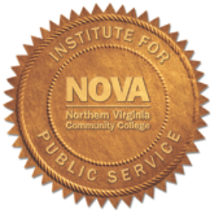
Northern Virginia Community College (NOVA), Alexandria
5000 Dawes Avenue, Alexandria, VA
October 23-26, 2015

AGENDA

Friday, October 23, 2015
Northern Virginia Community College
(8:00 a.m. – 4:30 p.m.; NOVA, Bisdorf Building 158; USIP)

Time Activity/Presentation Presenter/Organization

8:00 a.m. Breakfast at NOVA

9:00 a.m. Welcome David J. Smith, Educational
Program Overview Consultant, Seminar Director
Introductions Jimmie McClellan
Dean of Liberal Arts
NOVA/Alexandria

Linda M. Campos, NOVA Institute for
Public Service

10:00 a.m. “Peace, Pedagogy, and Daryn Cambridge
the Power of Today’s U.S. Institute of Peace
Global Conflicts”

11:30 a.m. Lunch (provided by NOVA) Chip Hauss
Alliance for Peacebuilding Alliance for Peacebuilding

12:45 p.m. Leave for USIP

2:30 p.m. U.S. Institute of Peace
2301 Constitution Avenue, NW

Hosted by: Jeff Helsing, Megan Chabalowski

4:30 p.m. End of Day; Dinner on Your Own

Saturday, October 24, 2015
(8:00 a.m. - 8:00 p.m.; NOVA, Bisdorf Building 158)

Time Activity/Presentation Presenter/Organization

8:00 a.m. Breakfast at NOVA

9:00 a.m. Debrief Smith, Campos

9:30 a.m. “It’s High Time for Peace Education” Colman McCarthy, Center for
Teaching Peace
10:45 a.m. Break

11:00 a.m. The Truth Telling Project Dave Ragland
Juniata College

12:15 p.m. Lunch at NOVA Tsekani Browne
“Teaching & Learning About the Confederate Flag Montgomery College
Controversy: Theory, Practice & Conflict as Teaching
Moments”

1:30 p.m. “Teaching, Modeling, and Learning Peace” Cindy Epperson, St. Louis
Community College

2:45 p.m. Break

3:00 p.m. “Understanding Trends in Global Peacefulness” Michelle Breslauer
Institute for Economics and Peace
4:00 p.m. Break

4:15 p.m. Alumni Panel Al Carroll
Northern Virginia
Community College

Karen Davis
Pasco-Hernando State College

Maria Bryant
College of Southern Maryland
5:15 p.m. Dinner at NOVA

6:30 p.m. Film showing: Beneath the Blindfold
By: Ines Sommer & Kathy Berger

7:30 p.m. Skype with co-producer, co-director Kathy Berger
Beneath the Blindfold
8:00 p.m. End of day

Sunday, October 25, 2015
(8:00 a.m. - 6:30 p.m.; NOVA)

Time Activity/Presentation Presenter/Organization

8:00 a.m. Breakfast at NOVA

9:00 a.m. Debrief Smith, Campos

9:20 a.m. “Peacebuilding in Community Colleges: Smith
The Road Traveled, The Road Ahead”

10:30 a.m. Break. Sponsored by Gabriel Arteaga, The Democracy Commitment



11:00 a.m. The Peace Alliance & Dan Kahn, The Peace Alliance
Student Peace Alliance

12:00 p.m. Lunch at NOVA
“The Global Refugee Crisis & U.S. Advocacy ” Sara Ibrahim, U.S. Committee for Refugees and Immigrants
1:15 p.m. “Terrorism and the Overthrow of the State” David Alpher, Saferworld

2:45 p.m. Break. Sponsored by Elizabeth Wuerz, Sustained Dialogue

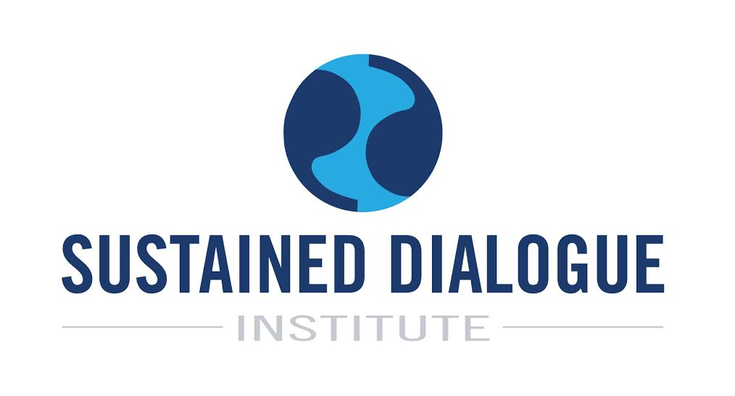

3:15 p.m. “Social Pain, Retaliation and Violence” Jacki Wilson, Independent
Consultant/JHW Consulting

4:30 p.m. Film showing: Circus Without Borders Mark Schulte, Pulitzer Center

5:30 p.m. Dinner at NOVA

6:45 p.m. End of day

Monday, October 26, 2015
(7:00 a.m. - 5:30 p.m.; DC site visits)

Time Organization/Location

7:00 a.m. Breakfast at NOVA/Leave for DC destinations

9:00 a.m. U.S. Department of State, U.S. Diplomacy Center,
23rd Street Entrance (between C & D Streets), NW

Hosted by: Lauren Krizner Fischer

11:30 a.m. U.S. Agency for International Development
Building SA-44, 301 4th St SW
Hosted by: Barbara Schneeman, Christie Vilsack

1:00 p.m. Lunch on your own

2:30 p.m. U.S. Holocaust Memorial Museum,
100 Raoul Wallenberg Place, SW

Hosted by: Christina Chavarria, Sonia Booth, JoAnna
Wasserman

5:00 p.m. Closing and Debriefing

5:30 p.m. End of Day; End of Program

PROGRAM CONTACT INFORMATION

Linda M. Campos lcampos@nvcc.edu
786-427-7626 (cell)
David J. Smith davidjsmith@fulbrightmail.org
240-855-4556 (cell)

